Beautifully animated music video helps new music artist, RXTH, overcome lockdown limitations.
RXTH, a Sussex based singer-songwriter, has teamed up with a talented group of animators from Colombia to bring her new single, ‘Beauty in the Spaces’ to life.
Watch here: https://youtu.be/cUfDGdDHZ78
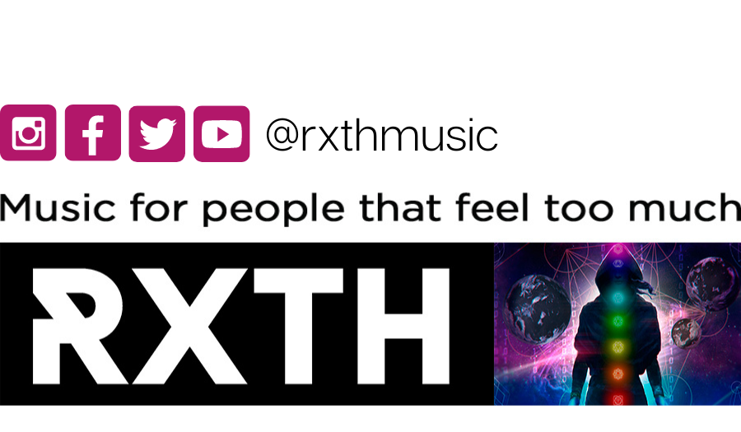
Linktree: https://linktr.ee/Rxth
Web: www.RxthMusic.com
Youtube: https://bit.ly/RxthYoutube
Insta: https://www.instagram.com/rxthmusic/
FB: https://www.facebook.com/RxthMusic
Animation: by DavisVegas and team
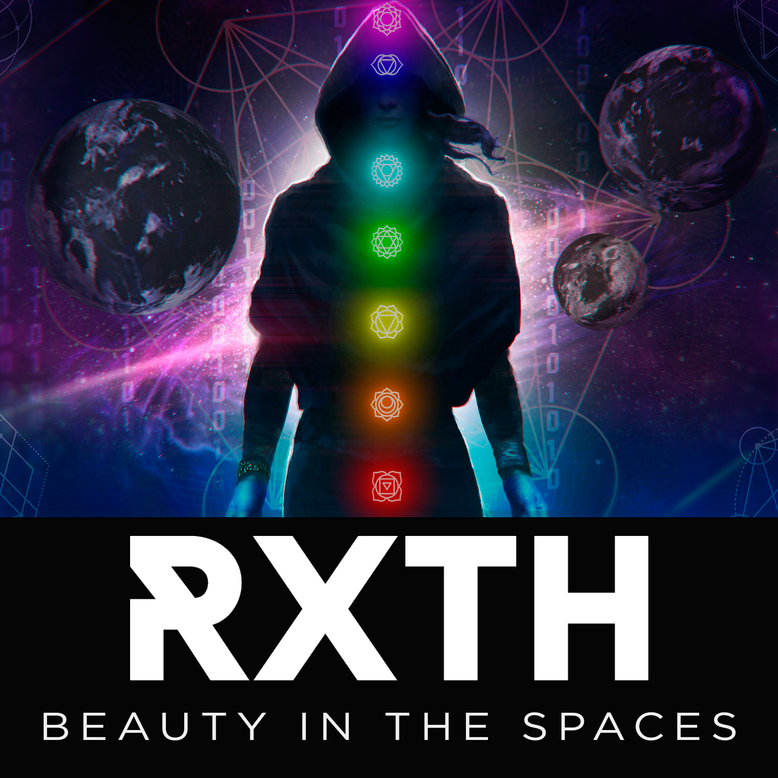
Released on 21.01.21, ‘Beauty in the Spaces’ is a dusky electro-pop track that touches on the uncertainty of today’s challenging times whilst highlighting the opportunity for positive change. The creative use of animation for the video in a lockdown-friendly way was therefore symbolic in more ways than one.

“With the limitations of lockdown, I was looking for creative ways to express the song’s themes visually. Animation seemed a great way to both communicate the uplifting intention behind the song and a chance to collaborate with creative people in another part of the world - without leaving the house.
In our current more isolated lives, we have had to seek creative and technological solutions to connection and creativity. It has in some ways made the world seem a bit smaller – which is at least a little silver lining we can clutch at.
In fact, the whole process was geographically unbound; my producer is based in London, the mastering was completed in Amsterdam, the animation in Colombia, and the song was written and recorded in my home studio Sussex, UK.
If necessity is the mother of invention, I think creativity maybe its father!”
-RXTH


Releasing conscious music for people who feel too much, RXTH has a subtle lyrical leaning towards personal transformation – her overriding passion.
“The aim is that my music leaves you better than it found you and to remind you that you aren't alone with your big feelings and big questions”.

‘Beauty in the Spaces’ is available on all the usual platforms from 21.01.21.

Photo by David Myers, Brighton
EPK: https://www.rxthmusic.com/epk
Contact: Darren@rxthmusic.com
RXTH Bio:
Rxth, is a Sussex (UK) based songwriter releasing conscious music for people who feel too much, with a lyrical leaning towards all things transformational.
Sonically, it’s dulcet toned vocals meets dusky electronic-pop. Influences such as Kate Bush, Portishead and Nine Inch Nails reveal themselves in subtle ways.
Rxth's lyrical themes range from emotional explorations, human nature, and self-reflection, to questions of consciousness and where we came from.
With a keen interest in the big questions in life, her influences extend beyond personal and musical ones, to include transformational thought leaders such Joe Dispenza, Scott Mandelker, and the Law of One material, which adds an interesting perspective to her lyrics.
Captivated by themes of transformation and the power of the mind, Rxth's aim is that her music leaves you better than it found you and to remind you that you aren't alone with your big feelings and big questions.

Background:
Rxth has written music since she was a child and says it has always been a part of how she processes her inner and outer world. She credits it as being her therapy before she knew what therapy was.
She went on to study music at university, then writing and gigging in bands in London, playing small festivals, working in the industry, and later writing and producing professionally for commissions (film and products).

While all great experiences, it was her passion for writing and sharing her own music that kept calling to her and that she is excited to finally be releasing now.

Her other passions of personal transformation, psychology and spirituality are subtly woven into her lyrics.

She aims to be uplifting and consciousness-raising, whilst fearlessly exploring the depths to bring light where it’s needed.

She advocates for mental health and wellbeing and also enjoys having one foot in the mystical, spiritual and unknown.

Lyrical Themes:
Transformation, truth seeking, conscious community, bringing the light to the darkness, human emotions, relationships, love, desire, the journey/ struggle, authentic self expression, the shift/awakening, waking up, personal responsibility and growth, self reflection, life in all it’s messy beauty, catalyst, universal connection, the power of our minds, self belief, and trying to make sense of all the feels.

2021 will see several single releases followed by an EP in late spring/ early summer.

