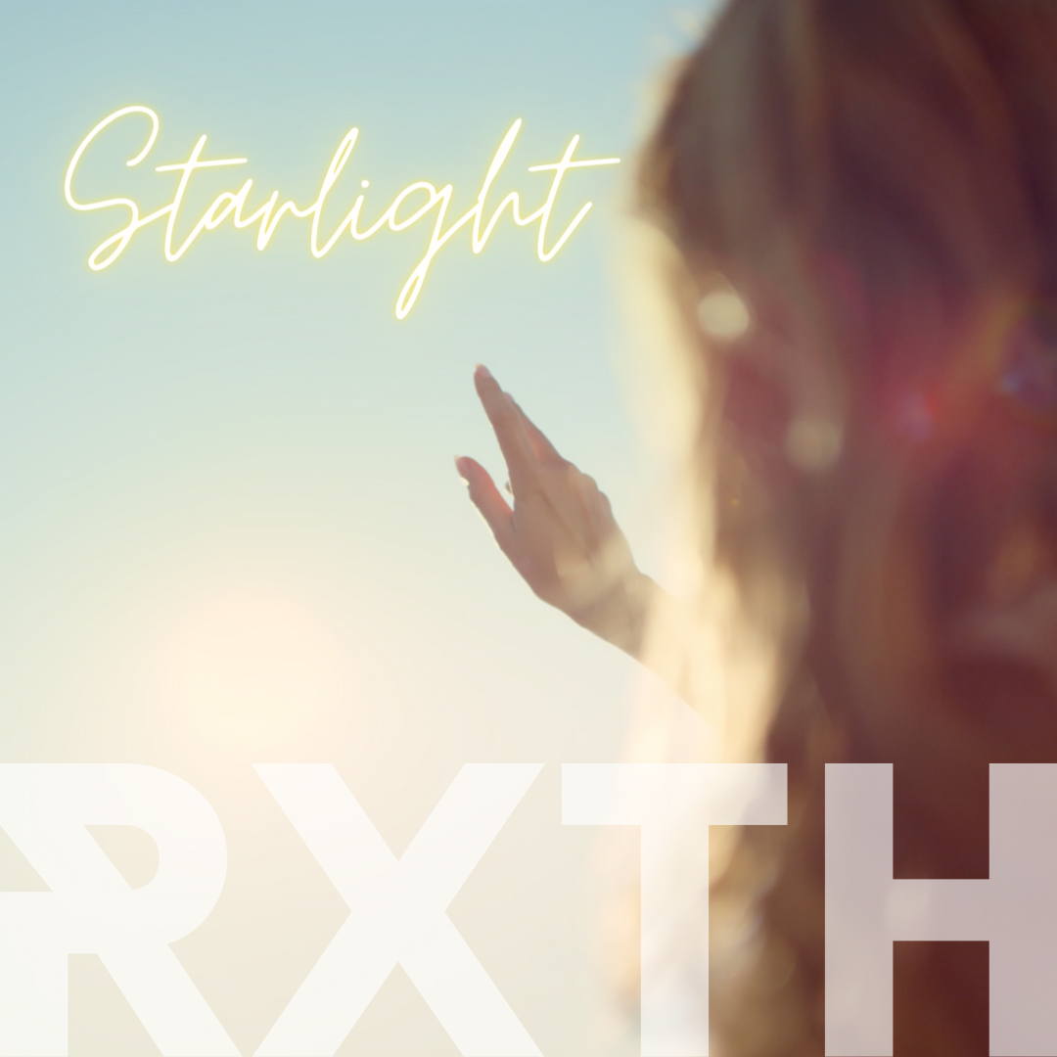

‘Starlight’ by RXTH

Single release: 01/07/22

Interest point: The Video focuses on themes of self-worth for women and girls. Lyrics are positive and universal.

'Starlight' is the fourth single from Sussex-based, singer-songwriter, Rxth (pronounced Ruth).

It’s a gently building, positive and affirming pop track, that aims to be an antidote to the many messages of ‘not enoughness’ that we are presented with daily.

The Song:
When speaking about its creation Rxth says: ‘‘’Starlight’ is one of those songs that, lyrically and melodically, arrived almost as a fully formed download. It was exactly what I needed to hear at the time, yet I didn’t feel like it was just for me. It’s a reminder that we’re all a ‘work in progress’ and not only is that ‘okay’, but it is as it should be. Our individual journeys of growth are unique, sacred, and beautiful. Even the hard stuff”.

The Production:
Regarding production, Rxth shares how the track evolved: “I worked with ED Seed for the production, and he really helped take it to the next level. From its early incarnation as a piano/vocal track, he managed to take the theme of light and put sound to it with those beautiful glassy strings at the beginning and throughout. Then he sonically mirrored the topic of personal evolution with the way the track builds and gathers momentum throughout, we both loved the results”.

Lyrics:
Known to have an interest in mystical and esoteric themes, when discussing the lyrics, Rxth explains: “The lyrics also subtly speak to the known origins of energy and the source of all life on earth; the stars and our sun. So, both metaphorically and literally, we are the stuff of starlight turning into something conscious and ‘beautiful’. Starlight is, of course, already beautiful, and essential. Perhaps then we can appreciate that so are we”.

The Video:
The video sees a diverse cast of women and girls receiving the same affirming message and shares glimpses of their own transformations or celebrations of self. Created by Rxth herself, she says: “In the video I focus on women and girls, as right now messages of their innate worth are as important as they’ve ever been. Any message, art or song that speaks to this is something I think we need a lot more of. I wanted to contribute and amplify that message. It’s a love note, a self-love note, for all of us”.

About RXTH:
Rxth is a UK-based singer-songwriter writing music for people who feel too much and are interested in the big questions - like why are we here and are we alone? Her sound ranges from emotional to thought provoking pop with visuals to match.

Starlight is her fourth release and the third single from her forthcoming EP.
You can find her @RxthMusic on socials, www.RxthMusic.com or https://linktr.ee/Rxth
RXTH Bio
Rxth, is a Sussex (UK) based songwriter releasing conscious music for people who feel ‘too much’.
Sonically, it’s dulcet toned vocals meets dusky electronic-pop. Influences such as Kate Bush and Tori Amos reveal themselves in subtle ways.
Dancing between the light and the dark, the alt and the pop - 'contrast', both visually and sonically, is a theme she enjoys exploring.
Rxth's lyrical themes range from emotional explorations, human nature, and self-reflection, to questions of consciousness and where we came from.
It's this interest in the big questions in life that sees her influences extend beyond musical ones, into the realms of personal and spiritual development, which adds an interesting, albeit subtle, perspective to some of her lyrics and videos.
Rxth's aim is that her music leaves you better than it found you and to remind you that you aren't alone with your big feelings and big questions.
Background:
Rxth has written music since she was a child and says it has always been a part of how she processes her inner and outer world. She credits it as being her therapy before she knew what therapy was.
She went on to study music at university, then writing and gigging in bands in London, playing small festivals, working in the industry, and later writing and producing professionally for commissions (film and products).
While all great experiences, it was her passion for writing and sharing her own music that kept calling to her and that she is excited to be releasing now.
Her other passions of personal transformation, psychology, and spirituality are subtly woven into her lyrics.
She aims to be uplifting and consciousness-raising, whilst fearlessly exploring the depths to bring light where it’s needed.
She advocates for mental health and wellbeing and also enjoys having one foot in the mystical, spiritual and unknown.
You can find her at www.RxthMusic.com @RxthMusic https://linktr.ee/Rxth

